Color Scheme Editor 

*(Updated 2014-06-13 by Jinsol Kim)*

## Overview

The Color Scheme Editor will help override colors on Revit elements with predefined color schemes stored in BIM Collaboration Format (BCF) 2.0. This tool resembles the Revit built-in color scheme editor for spatial elements, but more extended groups of categories can be applied with filtering elements by parameter rules like the view filters in Visibility/Graphic Overrides option.

*\*By the limitation of Revit API, the Color Scheme Editor will be only available in 2014 and 2015 versions of Revit.*

## Installation

Select the target software as Revit_2014 or Revit_2015, and you will find the Color Editor in the list of tools.

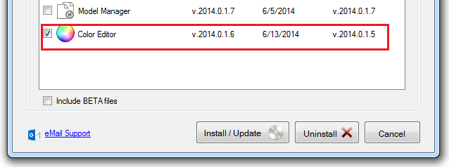

The Color Editor button will appear in the list of drop-down buttons of Utilities panel in the HOK tab.

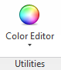

Contents

Overview 1

Installation 1

***1.*** ***Creating a Color Scheme*** 3

***2.*** ***Creating Color Definitions*** 6

2.1 Editing Color Values 6

2.2 Adding a Custom Value Definition 7

2.3 Creating Definitions by Range 8

2.4 Adding a Custom Range Definition 9

***3.*** ***Overriding Colors*** 10

***4.*** ***Importing Schemes*** 11

***5.*** ***BCF File*** 13

5.1 Color Scheme Information 13

5.2 Markup and Visualization Information 14

# ***Creating a Color Scheme***

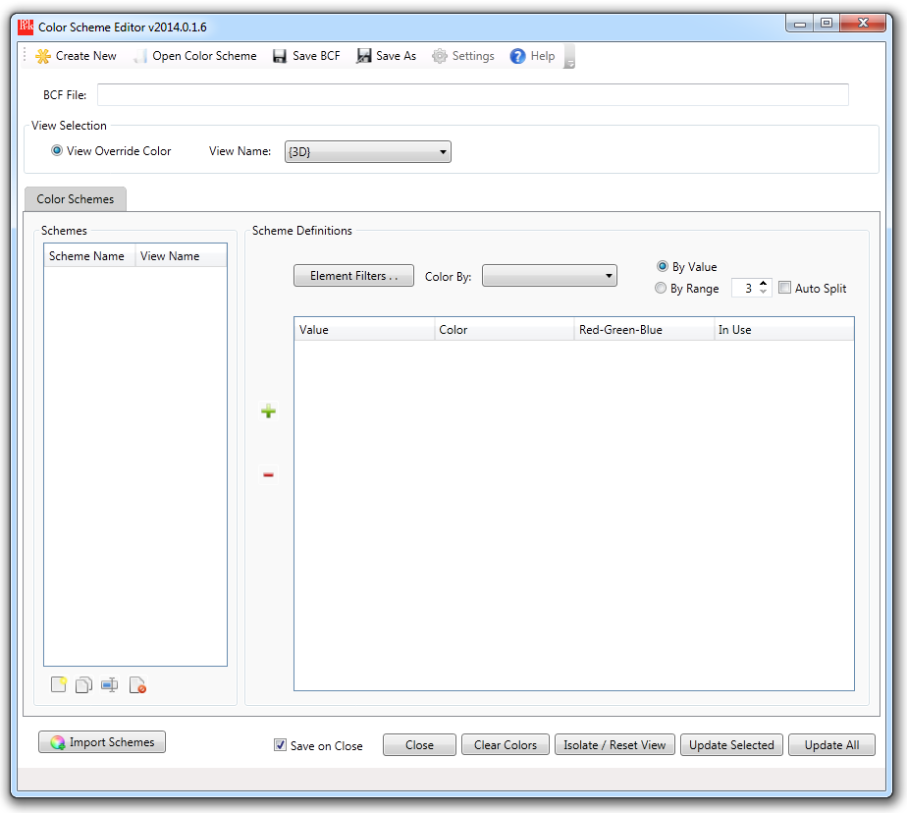

In order to start creating a new BCF file, click “Create New” button from the tool bar located on the top of the main window. This will initialize all the settings of the Color Scheme Editor.

*\*\* Note: more information about the details of BCF file will be described in the later chapter.*

On the bottom left corner of the UI, you will find four buttons for managing color schemes such as  creating a new scheme,  duplicating, renaming, and  deleting from a selected scheme.

Click the create button, and enter a new name for the color scheme and hit Enter key or click OK.

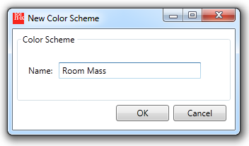

This will direct you to the selection window to make a group of categories to be applied and parameter filter rules to confine Revit elements.

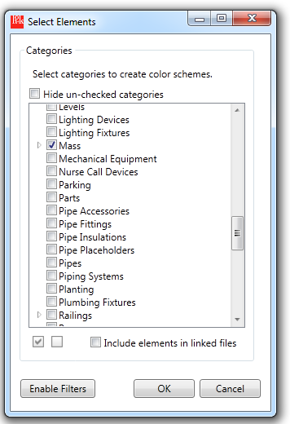

After making selections of categories, click ***Enable Filters*** button to expand more options for the parameter filter rules.

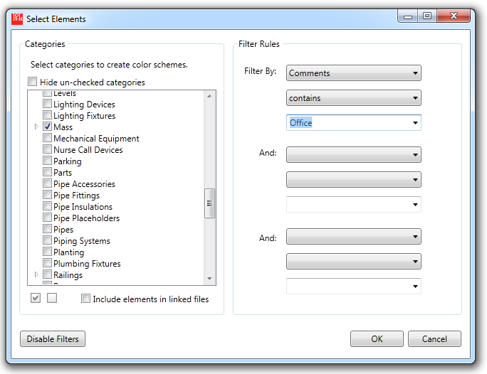

Up to three filter rules can be specified by selecting a parameter name, a criteria string, and a parameter value. The more categories you select, the less filterable parameters will be displayed in the dropdown box.

Click ***Disable Filters*** not to apply filter rules.

A new scheme with the name entered from the previous step will appear in the list of the schemes.

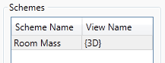

If you want to modify the selection of categories and filter rules, click button to go back to the Select Elements window.

# ***Creating Color Definitions***

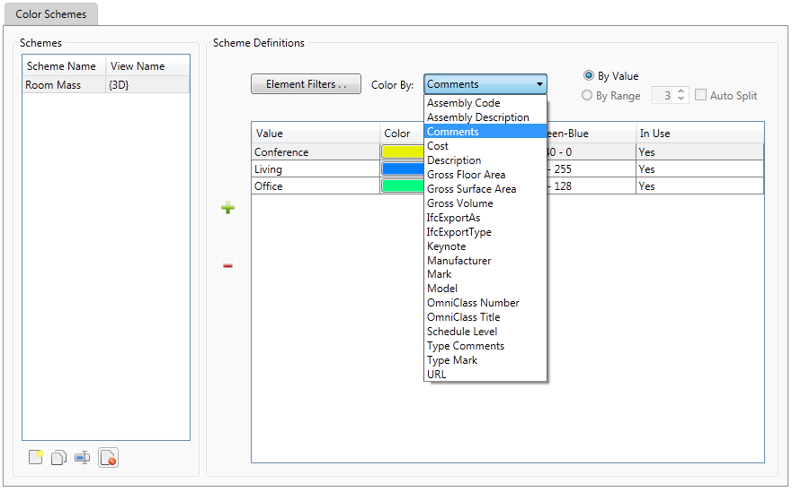

Pull down the ***Color By*** option, and specify a name of a parameter to programmatically generate a series of color definitions based on all possible parameter values from the selected elements.

**Note: when you make changes on the ***Color By*** value, the user-defined color scheme entries can be lost if the storage types are different.

## Editing Color Values

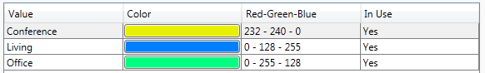

In order to specify a color other than the predefined one, click a color filled button in the ***Color*** column to enter to the Windows color dialog.

RGB values will be updated accordingly by the selected color.

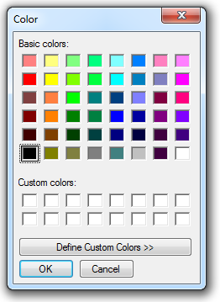

## Adding a Custom Value Definition

In addition to the existing color definitions, user-defined custom definitions can be inserted in the set of the color definition. Only those custom definitions can be inserted by the  ***Add*** button, or either deleted by the  ***Delete*** button.

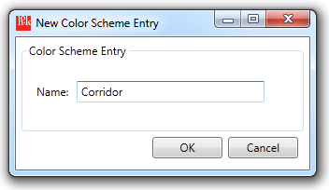

Click ***Add*** button and enter a new name for the color scheme entry.

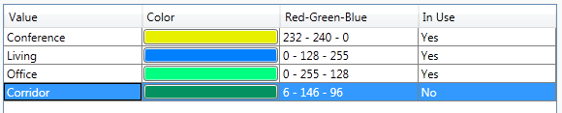

A new row will be created on the bottom of the list with the ***In Use*** value as No, which means the value, “Corridor”, cannot be found from any of the selected elements.

Select a row and click ***Delete*** button to delete the custom definition.

## Creating Definitions by Range

If the storage type of the selected parameter is number, the radio button, ***By Range***, will become enabled with ***Auto Split*** option.

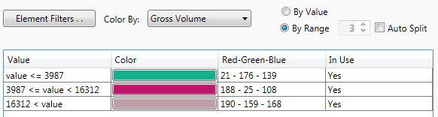

By specifying the number of the color definition with enabling the ***Auto Split*** option, color definitions will be programmatically generated with evenly divided ranges from minimum to maximum values.

** Note: default unit is feet decimal. The unit suffix will be supported at the future development.

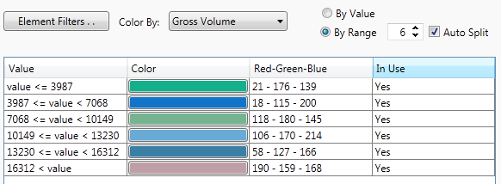

## Adding a Custom Range Definition

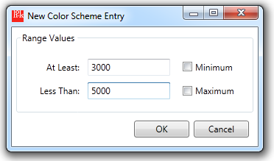

Click ***Add*** button and enter a starting value and an ending value to define a range of values.

You can set those values as either ***Minimum***, which will be displayed at the first row, or ***Maximum***, which will be displayed at the last row, for the entire range sets.

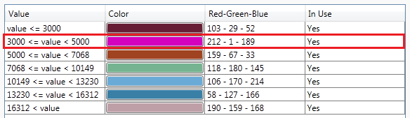

# ***Overriding Colors***

Before applying the override colors, make sure each scheme has mapped to an existing view that will be graphically illustrated by the scheme. Select a scheme and specify a view name from the drop down box.

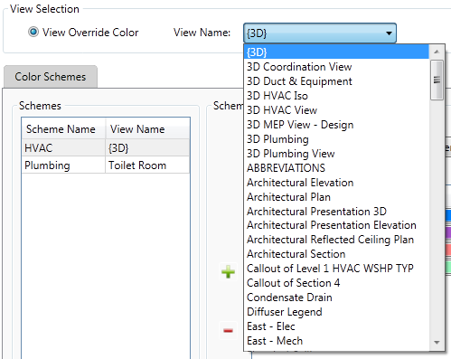

Click ***Apply*** button to override colors only by the selected scheme in the UI, or ***Update All*** button applying colors by all color shcemes at once.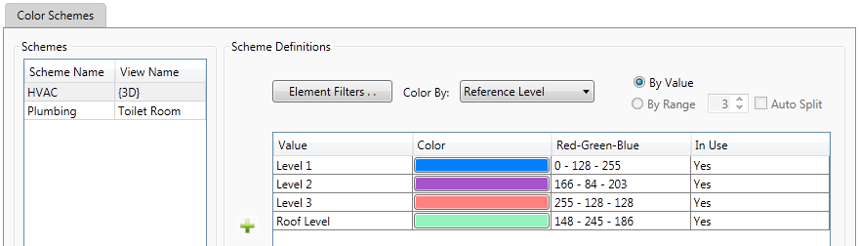

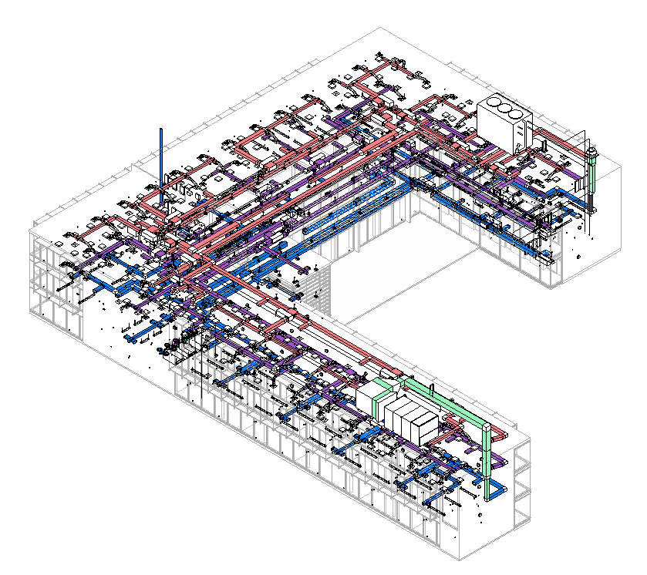

# ***Importing Schemes***

Click ***Import Schemes*** button on the left bottom corner to merge imported color schemes into the active BCF file.

In the Open dialog, select a BCF zip file that contains color schemes to be imported.

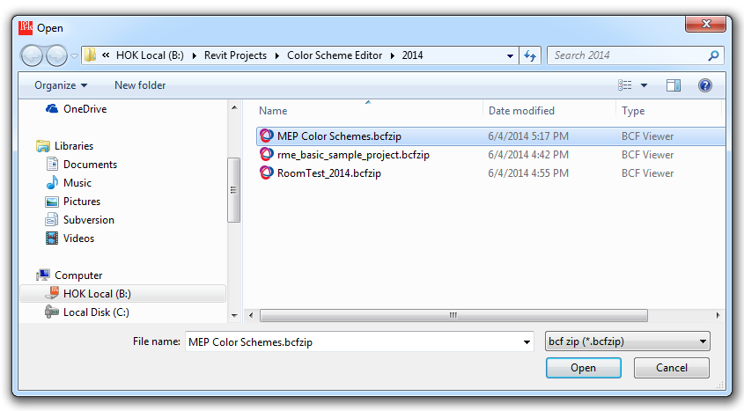

Select color schemes to be imported and click ***OK*** from the Import Color Schemes dialog.

Imported color schemes will be inserted into the list of color schemes.

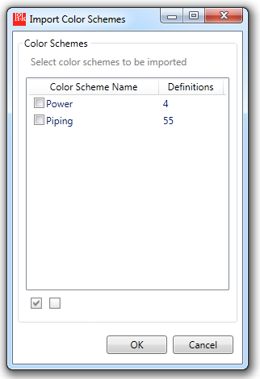 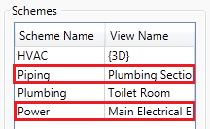

# ***BCF File***

BCF zip file can be extracted by changing the file extension as “.zip”. Once the zip file extracted, in the root folder there will be sub-folders named with GUID of Topics. Each GUID folder will consists of four files with prefixed names, colorscheme.xml, markup.bcf, snapshot.png, and viewpoint.bcfv.

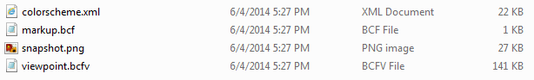

## Color Scheme Information

The color scheme file, colorscheme.xml, is the most important file that contains the information of color schemes and color definitions to directly communicate with the Color Scheme Editor. The colorscheme.xml will be created by storing user’s inputs into the following data structure.

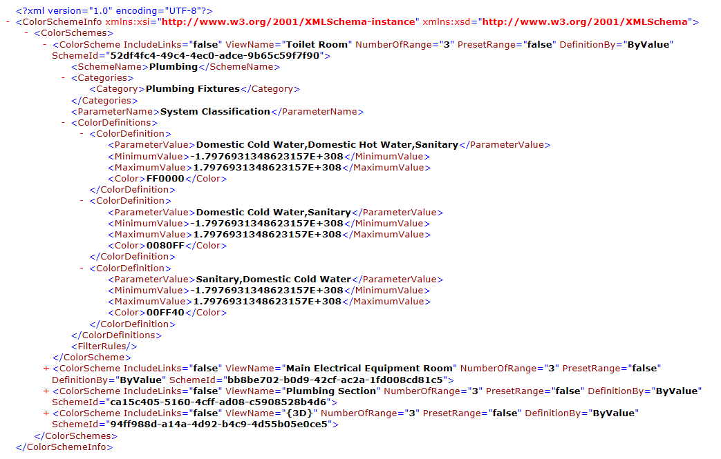

ColorScheme Class

|  |  |  |
| --- | --- | --- |
| Properties | Sub-Properties | Description |
| SchemeName |  | A name of the color scheme |
| Categories | Category | Names of the selected categories |
| ParameterName |  | A Name of the parameter to determine color values |
| ColorDefinition | ParameterValue | The value of the selected parameter |
| MinimumValue | Starting value (default: minimum of double type) |
| MaximumValue | Ending value (default: maximum of double type) |
| FilterRule | ParameterId | Element Id of the Parameter |
| CriteriaName | Criteria strings to filter by the parameter |
| RuleValue | Values that will be compared |
| ParameterStorageType | Storage type of the parameter |

|  |  |
| --- | --- |
| Attributes | Description |
| IncludeLinks | To determine whether including elements from linked files or not |
| ViewName | A name of 3D or plan view in which the override colors will be visualized |
| NumberOfRange | The number of ranges if the color definition was generated by ranges |
| PresetRange | Enabling or disabling the auto split function |
| DefinitionBy | Color definitions by parameter values or by value ranges |
| SchemeId | ID of scheme as GUID |

## Markup and Visualization Information

**markup.bcf**: the markup file will have consistent values generated by the Color Scheme Editor.

<Topic Guid="78ef5c87-8048-4b4c-87fc-ffdfacdfbd77">

<Title>Color Schemes Editor</Title>

<BimSnippet>

<Reference>colorscheme.xml</Reference>

<ReferenceSchema>C:\Users\Jinsol.Kim\Documents\01. RevitAPI\_Revit Versions\HOK.ColorSchemeEditor\HOK.ColorSchemeEditor\bin\2014\Resources\colorscheme.xsd</ReferenceSchema>

</BimSnippet>

</Topic>

**viewpoint.bcfv**: this will contains the information of all elements colored by the Color Scheme Editor including the angle of the view point of those elements. (Under development)

<Component IfcGuid="2t0Vf4T_18Q8GXNYAAo8JX" Color="87B9F6">

<OriginatingSystem>Autodesk Revit 2014</OriginatingSystem>

<AuthoringToolId>305091</AuthoringToolId>

</Component>

**snapshot.png**: a screen captured image of the bounding box created by all colored elements. (Under development)

